### Testing, Deployment, and CI/CD Engineer and Websocket Implementer

Mohammed Alhutheily 胡天 1820222022

In this project, I was responsible for the crucial role of ensuring that the system was well-tested, deployed seamlessly, and integrated with real-time WebSocket functionalities. Additionally, I managed the continuous integration/continuous deployment (CI/CD) pipeline to automate testing and deployment, ensuring a smooth development workflow for the team. Below is a reflection on how I specialized in this role, the challenges faced, and the collaborative work within our four-person team.

Role Specialization

As the Testing, Deployment, WebSocket Integrator, and CI/CD Engineer, my responsibilities included:

WebSocket Integration: I integrated real-time WebSocket communication into the chat application to allow instant message updates without refreshing the page. This required configuring Django Channels and ensuring real-time communication between the client and server.

Testing: I wrote unit tests, integration tests, and end-to-end tests to ensure that the system's core functionalities were working as expected. This included testing WebSocket connections, database interactions, and frontend-backend communication.

Deployment: I handled the deployment process, ensuring that the application could be deployed to the production environment seamlessly. I worked on setting up the deployment pipeline for staging and production.

CI/CD Pipeline Setup: I built and maintained the CI/CD pipeline using GitHub Actions to automate testing, building, and deployment processes. This ensured faster and more efficient code integration with minimal manual intervention.

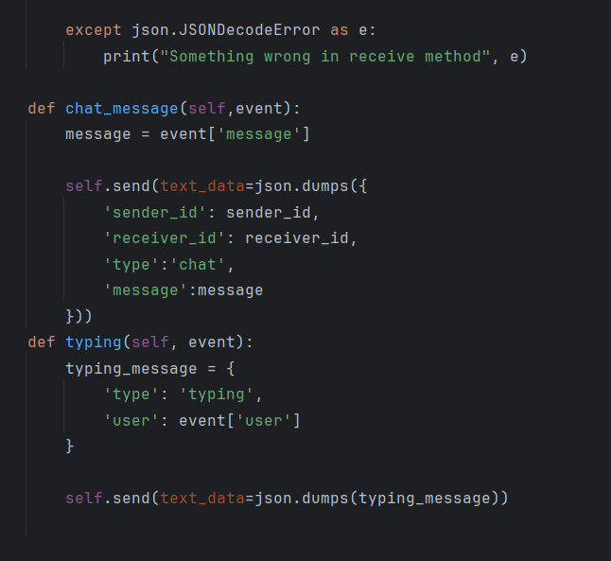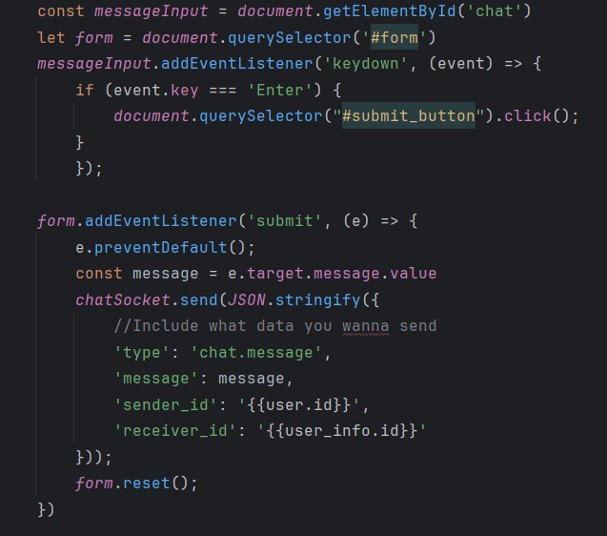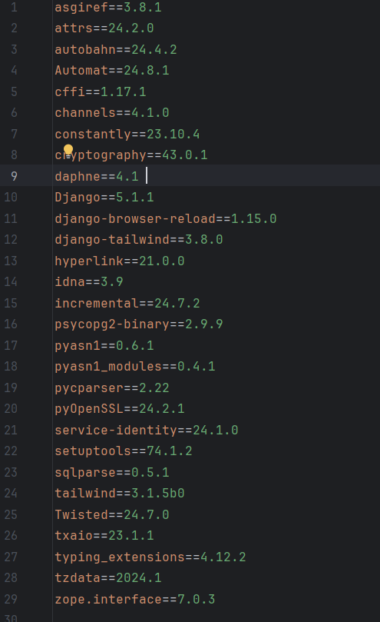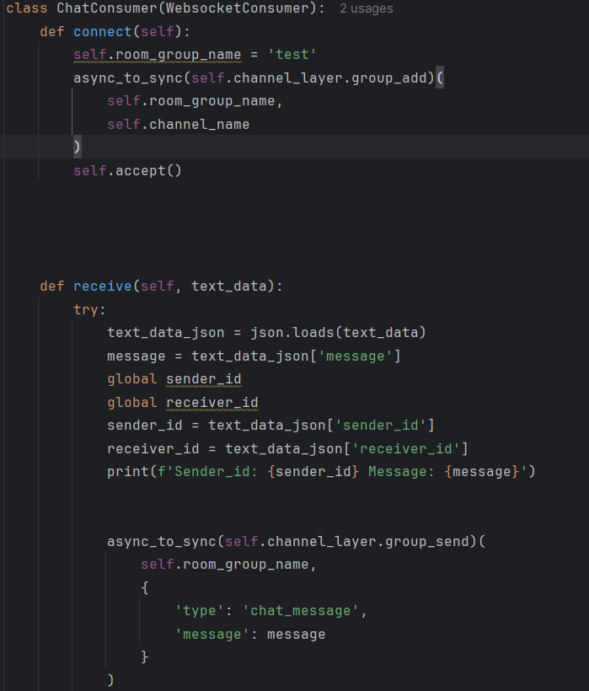

Key Challenges and Solutions

WebSocket Integration with Django Channels: Implementing real-time communication using WebSocket required integrating Django Channels to handle asynchronous messaging. The main challenge was ensuring that the WebSocket server could scale and manage multiple connections simultaneously. By implementing proper WebSocket message routing, we ensured that messages were delivered in real-time to the appropriate users in various chat rooms. I also coordinated closely with the backend developer to maintain a clean interface between WebSocket events and the database.

Testing Real-Time Features: Testing real-time features like WebSocket connections posed a challenge since traditional HTTP request/response testing methods weren’t sufficient. I needed to simulate multiple clients connecting and interacting in real-time.

Deployment with Real-Time Features: Deploying a WebSocket-integrated application involved additional complexity since WebSockets require persistent connections, unlike traditional HTTP requests. Configuring the server to handle both HTTP and WebSocket traffic without interference was a challenge..

CI/CD Pipeline for Real-Time Features: Implementing CI/CD pipelines that accounted for both WebSocket and HTTP testing posed another challenge. The pipeline needed to automate testing, build the application, and deploy it to production with minimal downtime.

Collaboration with the Team

Backend Developer: I collaborated closely with the backend developer to ensure that the WebSocket consumers were optimized and could handle real-time communication effectively. We coordinated on designing efficient WebSocket message routes and database queries to reduce latency.

Frontend Developer: The frontend and I worked on ensuring that the real-time user experience (UX) was smooth. This involved testing WebSocket connections from the frontend to the backend, debugging issues related to message delivery, and ensuring the user interface reflected real-time updates accurately.

DBA and ETL Engineer: Our collaboration ensured that the database could handle real-time updates without bottlenecks. This was critical as multiple users were writing and reading data simultaneously, requiring strong database performance and careful transaction management.

Performance and Reflection

As the WebSocket Integrator and CI/CD Engineer, I specialized in ensuring that real-time communication worked seamlessly and that deployment was automated and efficient. The WebSocket integration allowed for an interactive, real-time chat experience, which was a key feature of the app. By configuring the CI/CD pipeline, I reduced the time required to manually deploy updates and ensured that the entire team could integrate changes faster and with fewer bugs.

I faced significant challenges in scaling the WebSocket connections and balancing real-time performance with database constraints. However, through careful design, testing, and collaboration, I was able to deliver a solution that met the team’s needs and provided a robust user experience.

This project allowed me to enhance my skills in real-time application development and deployment, and I look forward to applying these lessons to future projects.